Assignment 2 - ANOVA - Blocking
Rushabh Barbhaya
2021-04-10

Questions
- What assumption must we test to include a variable as a blocking factor?
  - Kurtosis, Skewness, Normality, Independence of Observation, Variance test, and Additivity
  - Blocking technique should also help us reduce the Error
- Recognize the IV, DV, block and create a table for the following research statement.
  - Independent Variable: Motor Skill Test (condition)
  - Dependent Variable: Performance Score (Performance_score)
  - Blocking Variable: Age Group (Age)
Specification Table
Variable | #Levels
Motor Skill Test | 3
Age(Block) | 3

 | Test1 | Test2 | Test3
Age_60-69
Age_70_79
Age_80+

ANOVA

Hypothesis
Performance Scores of all elderly people are equal
Performance Scores of all elderly people may not be equal

Assumptions
- From the density plot, there seems to have 2 spikes which may affect our results
- We fail to reject the null hypothesis on kurtosis test
- We fail to reject the null hypothesis from skewness test
- We fail to reject the null hypothesis in normality test
- We fail to reject the null hypothesis for variance test
- The largest to smallest ratio of variance is less than 3. Which is not enough evidence to reject the null hypothesis
- Model1 –> Condition*Age, is not a significant factor
- Model2 –> Condition, is a significant factor
- Model3 –> Age, is a significant factor
- Model4 –> Condition+Age, is cannot be a blocker, it’s a significant factor
- Condition1 –> n = 28, Mean = 32.0714286, SD = 4.2854497
- Condition2 –> n = 30, Mean = 27.8666667, SD = 4.5768031
- Condition3 –> n = 31, Mean = 23.0645161, SD = 4.5529147

Summary
Observations from the study were analyzed by conducting a one-way analysis of variance using R version 4.0.5. First, all assumptions are met and no adjustments were made. Conditions has a significant effect on (F(2,86), p-value < 0.05).
A Tukey test was performed and there was a significant difference in Task 1 and 2, also Task 2 and 3, and Task 1 and 3 (all p-values < 0.001). Cohen’s D effect are too large.
library(readxl)
library(moments)
library(pgirmess)
library(pastecs)
library(compute.es)
data <- read_excel("Lab3.xlsx")
summary(data)
# Denisty Plot
plot(density(data$Performance_score))
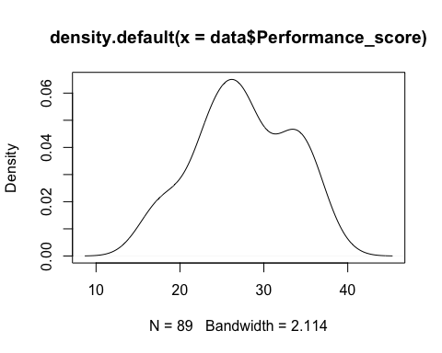
qqnorm(data$Performance_score)
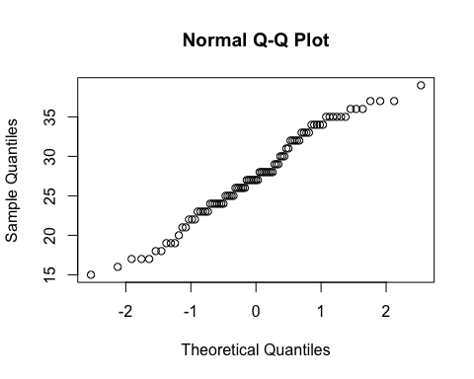
# Kurtosis Test
anscombe.test(data$Performance_score)
# Skewness Test
agostino.test(data$Performance_score)
# Normality Test
shapiro.test(data$Performance_score)
#Residual Plot
perf.lm = lm(Performance_score ~ Condition, data = data)
perf.res = resid(perf.lm)
plot(data$Performance_score, perf.res, ylab = "Residual", xlab = "Condition", main = "Independence of Observation")
abline(0, 0)
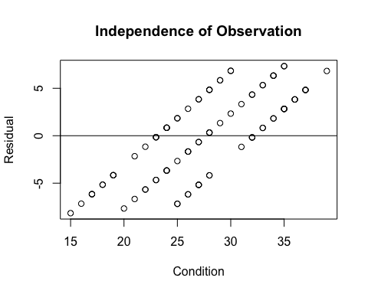
# Variance Test
bartlett.test(data$Performance_score, data$Condition)
tapply(data$Performance_score, data$Condition, var)
# ANOVA with Blocking
model1 = aov(Performance_score ~ factor(Condition)*factor(Age), data = data)
summary(model1)
model2 = aov(Performance_score ~ factor(Condition), data = data)
summary(model2)
model3 = aov(Performance_score ~ factor(Age), data = data)
summary(model3)
model4 = aov(Performance_score ~ factor(Condition)+factor(Age), data = data)
summary(model4)
anova(model1, model2)
#Pairwise t test
pairwise.t.test(data$Performance_score, data$Condition, paired = FALSE, p.adjust.method = "bonferroni")
#Tukey's test
TukeyHSD(model1)
by(data$Performance_score, data$Condition, stat.desc)
mes(27.8666667, 32.0714286, 4.5768031, 4.2854497, 30, 28)
mes(23.0645161, 27.8666667, 4.5529147, 4.5768031, 31, 30)
mes(23.0645161, 32.0714286, 4.5529147, 4.2854497, 31, 28)
## Age Performance_score Condition
## Min. :1 Min. :15.00 Min. :1.000
## 1st Qu.:1 1st Qu.:24.00 1st Qu.:1.000
## Median :2 Median :27.00 Median :2.000
## Mean :2 Mean :27.52 Mean :2.034
## 3rd Qu.:3 3rd Qu.:32.00 3rd Qu.:3.000
## Max. :3 Max. :39.00 Max. :3.000
##
## Anscombe-Glynn kurtosis test
##
## data: data$Performance_score
## kurt = 2.2365, z = -2.0554, p-value = 0.03984
## alternative hypothesis: kurtosis is not equal to 3
##
##
## D'Agostino skewness test
##
## data: data$Performance_score
## skew = -0.11171, z = -0.45976, p-value = 0.6457
## alternative hypothesis: data have a skewness
##
##
## Shapiro-Wilk normality test
##
## data: data$Performance_score
## W = 0.9755, p-value = 0.09018
##
##
## Bartlett test of homogeneity of variances
##
## data: data$Performance_score and data$Condition
## Bartlett's K-squared = 0.14381, df = 2, p-value = 0.9306
##
## 1 2 3
## 18.36508 20.94713 20.72903
## Df Sum Sq Mean Sq F value Pr(>F)
## factor(Condition) 2 1199.0 599.5 313.667 <2e-16 ***
## factor(Age) 2 1549.6 774.8 405.389 <2e-16 ***
## factor(Condition):factor(Age) 4 22.6 5.7 2.961 0.0246 *
## Residuals 80 152.9 1.9
## ---
## Signif. codes: 0 '***' 0.001 '**' 0.01 '*' 0.05 '.' 0.1 ' ' 1
## Df Sum Sq Mean Sq F value Pr(>F)
## factor(Condition) 2 1199 599.5 29.89 1.4e-10 ***
## Residuals 86 1725 20.1
## ---
## Signif. codes: 0 '***' 0.001 '**' 0.01 '*' 0.05 '.' 0.1 ' ' 1
## Df Sum Sq Mean Sq F value Pr(>F)
## factor(Age) 2 1550 774.9 48.48 7.97e-15 ***
## Residuals 86 1374 16.0
## ---
## Signif. codes: 0 '***' 0.001 '**' 0.01 '*' 0.05 '.' 0.1 ' ' 1
## Df Sum Sq Mean Sq F value Pr(>F)
## factor(Condition) 2 1199.0 599.5 286.9 <2e-16 ***
## factor(Age) 2 1549.6 774.8 370.8 <2e-16 ***
## Residuals 84 175.5 2.1
## ---
## Signif. codes: 0 '***' 0.001 '**' 0.01 '*' 0.05 '.' 0.1 ' ' 1
## Analysis of Variance Table
##
## Model 1: Performance_score ~ factor(Condition) * factor(Age)
## Model 2: Performance_score ~ factor(Condition)
## Res.Df RSS Df Sum of Sq F Pr(>F)
## 1 80 152.91
## 2 86 1725.19 -6 -1572.3 137.1 < 2.2e-16 ***
## ---
## Signif. codes: 0 '***' 0.001 '**' 0.01 '*' 0.05 '.' 0.1 ' ' 1
##
## Pairwise comparisons using t tests with pooled SD
##
## data: data$Performance_score and data$Condition
##
## 1 2
## 2 0.0017 -
## 3 6e-11 0.0002
##
## P value adjustment method: bonferroni
## Tukey multiple comparisons of means
## 95% family-wise confidence level
##
## Fit: aov(formula = Performance_score ~ factor(Condition) * factor(Age), data = data)
##
## $`factor(Condition)`
## diff lwr upr p adj
## 2-1 -4.204762 -5.072310 -3.337214 0
## 3-1 -9.006912 -9.867679 -8.146146 0
## 3-2 -4.802151 -5.647707 -3.956594 0
##
## $`factor(Age)`
## diff lwr upr p adj
## 2-1 -4.516166 -5.369099 -3.663233 0
## 3-1 -10.310345 -11.177377 -9.443313 0
## 3-2 -5.794179 -6.647112 -4.941246 0
##
## $`factor(Condition):factor(Age)`
## diff lwr upr p adj
## 2:1-1:1 -2.922222e+00 -4.947474 -0.8969700 0.0005097
## 3:1-1:1 -8.022222e+00 -10.047474 -5.9969700 0.0000000
## 1:2-1:1 -2.922222e+00 -4.947474 -0.8969700 0.0005097
## 2:2-1:1 -8.722222e+00 -10.747474 -6.6969700 0.0000000
## 3:2-1:1 -1.276768e+01 -14.748843 -10.7865103 0.0000000
## 1:3-1:1 -9.666667e+00 -11.744532 -7.5888017 0.0000000
## 2:3-1:1 -1.342222e+01 -15.447474 -11.3969700 0.0000000
## 3:3-1:1 -1.872222e+01 -20.747474 -16.6969700 0.0000000
## 3:1-2:1 -5.100000e+00 -7.071236 -3.1287642 0.0000000
## 1:2-2:1 1.421085e-14 -1.971236 1.9712358 1.0000000
## 2:2-2:1 -5.800000e+00 -7.771236 -3.8287642 0.0000000
## 3:2-2:1 -9.845455e+00 -11.771369 -7.9195406 0.0000000
## 1:3-2:1 -6.744444e+00 -8.769697 -4.7191922 0.0000000
## 2:3-2:1 -1.050000e+01 -12.471236 -8.5287642 0.0000000
## 3:3-2:1 -1.580000e+01 -17.771236 -13.8287642 0.0000000
## 1:2-3:1 5.100000e+00 3.128764 7.0712358 0.0000000
## 2:2-3:1 -7.000000e-01 -2.671236 1.2712358 0.9674422
## 3:2-3:1 -4.745455e+00 -6.671369 -2.8195406 0.0000000
## 1:3-3:1 -1.644444e+00 -3.669697 0.3808078 0.2078478
## 2:3-3:1 -5.400000e+00 -7.371236 -3.4287642 0.0000000
## 3:3-3:1 -1.070000e+01 -12.671236 -8.7287642 0.0000000
## 2:2-1:2 -5.800000e+00 -7.771236 -3.8287642 0.0000000
## 3:2-1:2 -9.845455e+00 -11.771369 -7.9195406 0.0000000
## 1:3-1:2 -6.744444e+00 -8.769697 -4.7191922 0.0000000
## 2:3-1:2 -1.050000e+01 -12.471236 -8.5287642 0.0000000
## 3:3-1:2 -1.580000e+01 -17.771236 -13.8287642 0.0000000
## 3:2-2:2 -4.045455e+00 -5.971369 -2.1195406 0.0000001
## 1:3-2:2 -9.444444e-01 -2.969697 1.0808078 0.8583631
## 2:3-2:2 -4.700000e+00 -6.671236 -2.7287642 0.0000000
## 3:3-2:2 -1.000000e+01 -11.971236 -8.0287642 0.0000000
## 1:3-3:2 3.101010e+00 1.119844 5.0821766 0.0001161
## 2:3-3:2 -6.545455e-01 -2.580459 1.2713685 0.9750171
## 3:3-3:2 -5.954545e+00 -7.880459 -4.0286315 0.0000000
## 2:3-1:3 -3.755556e+00 -5.780808 -1.7303033 0.0000028
## 3:3-1:3 -9.055556e+00 -11.080808 -7.0303033 0.0000000
## 3:3-2:3 -5.300000e+00 -7.271236 -3.3287642 0.0000000
##
## data$Condition: 1
## nbr.val nbr.null nbr.na min max range
## 28.0000000 0.0000000 0.0000000 25.0000000 39.0000000 14.0000000
## sum median mean SE.mean CI.mean.0.95 var
## 898.0000000 33.0000000 32.0714286 0.8098739 1.6617239 18.3650794
## std.dev coef.var
## 4.2854497 0.1336220
## ------------------------------------------------------------
## data$Condition: 2
## nbr.val nbr.null nbr.na min max range
## 30.0000000 0.0000000 0.0000000 20.0000000 35.0000000 15.0000000
## sum median mean SE.mean CI.mean.0.95 var
## 836.0000000 27.5000000 27.8666667 0.8356061 1.7090064 20.9471264
## std.dev coef.var
## 4.5768031 0.1642393
## ------------------------------------------------------------
## data$Condition: 3
## nbr.val nbr.null nbr.na min max range
## 31.0000000 0.0000000 0.0000000 15.0000000 30.0000000 15.0000000
## sum median mean SE.mean CI.mean.0.95 var
## 715.0000000 24.0000000 23.0645161 0.8177276 1.6700226 20.7290323
## std.dev coef.var
## 4.5529147 0.1973991
## Mean Differences ES:
##
## d [ 95 %CI] = -0.95 [ -1.49 , -0.4 ]
## var(d) = 0.08
## p-value(d) = 0
## U3(d) = 17.17 %
## CLES(d) = 25.15 %
## Cliff's Delta = -0.5
##
## g [ 95 %CI] = -0.93 [ -1.47 , -0.4 ]
## var(g) = 0.07
## p-value(g) = 0
## U3(g) = 17.5 %
## CLES(g) = 25.44 %
##
## Correlation ES:
##
## r [ 95 %CI] = -0.43 [ -0.62 , -0.2 ]
## var(r) = 0.01
## p-value(r) = 0
##
## z [ 95 %CI] = -0.46 [ -0.73 , -0.2 ]
## var(z) = 0.02
## p-value(z) = 0
##
## Odds Ratio ES:
##
## OR [ 95 %CI] = 0.18 [ 0.07 , 0.48 ]
## p-value(OR) = 0
##
## Log OR [ 95 %CI] = -1.72 [ -2.7 , -0.73 ]
## var(lOR) = 0.25
## p-value(Log OR) = 0
##
## Other:
##
## NNT = -6.13
## Total N = 58Mean Differences ES:
##
## d [ 95 %CI] = -1.05 [ -1.59 , -0.52 ]
## var(d) = 0.07
## p-value(d) = 0
## U3(d) = 14.64 %
## CLES(d) = 22.85 %
## Cliff's Delta = -0.54
##
## g [ 95 %CI] = -1.04 [ -1.57 , -0.51 ]
## var(g) = 0.07
## p-value(g) = 0
## U3(g) = 14.95 %
## CLES(g) = 23.14 %
##
## Correlation ES:
##
## r [ 95 %CI] = -0.47 [ -0.65 , -0.25 ]
## var(r) = 0.01
## p-value(r) = 0
##
## z [ 95 %CI] = -0.51 [ -0.77 , -0.25 ]
## var(z) = 0.02
## p-value(z) = 0
##
## Odds Ratio ES:
##
## OR [ 95 %CI] = 0.15 [ 0.06 , 0.39 ]
## p-value(OR) = 0
##
## Log OR [ 95 %CI] = -1.91 [ -2.88 , -0.94 ]
## var(lOR) = 0.25
## p-value(Log OR) = 0
##
## Other:
##
## NNT = -5.85
## Total N = 61Mean Differences ES:
##
## d [ 95 %CI] = -2.03 [ -2.66 , -1.4 ]
## var(d) = 0.1
## p-value(d) = 0
## U3(d) = 2.1 %
## CLES(d) = 7.52 %
## Cliff's Delta = -0.85
##
## g [ 95 %CI] = -2.01 [ -2.63 , -1.39 ]
## var(g) = 0.1
## p-value(g) = 0
## U3(g) = 2.24 %
## CLES(g) = 7.79 %
##
## Correlation ES:
##
## r [ 95 %CI] = -0.72 [ -0.82 , -0.57 ]
## var(r) = 0
## p-value(r) = 0
##
## z [ 95 %CI] = -0.9 [ -1.17 , -0.64 ]
## var(z) = 0.02
## p-value(z) = 0
##
## Odds Ratio ES:
##
## OR [ 95 %CI] = 0.02 [ 0.01 , 0.08 ]
## p-value(OR) = 0
##
## Log OR [ 95 %CI] = -3.69 [ -4.83 , -2.55 ]
## var(lOR) = 0.34
## p-value(Log OR) = 0
##
## Other:
##
## NNT = -5.05
## Total N = 59

